Github Copilot
TL have multiple branches
TL monitors and point outs mistakes
Finally merges the wrks of all branches

For this we are using the platform: Git
Git distributed, version control system: We can work offline and later sync the work
Git is a command line tool
We are working in a file: the changes we are doing is seen
Git init: start tracking a floder(single time)
Add: adding the folder(repeated)
Commit: saving the change. Recording it(our tasks are recorded)
Push: we are adding the change (TL can see what changes we have made)
Pull: fetch, merge remove

To monitor by Git:
Save a file in new folder in vs code
Source control: check
Git initialize: new terminal git initenter
Go to file explorer choose folder we have saved the file view showhidden files
Hovering on u it is showing untracked
2. Now we have to add file
Git add file1.py
Now our file destination changes from changes to staged changes
U changes to A
Before giving to someone(say TL) this step checks(intermediate step)
3. commit
Git commit -m “first stage”
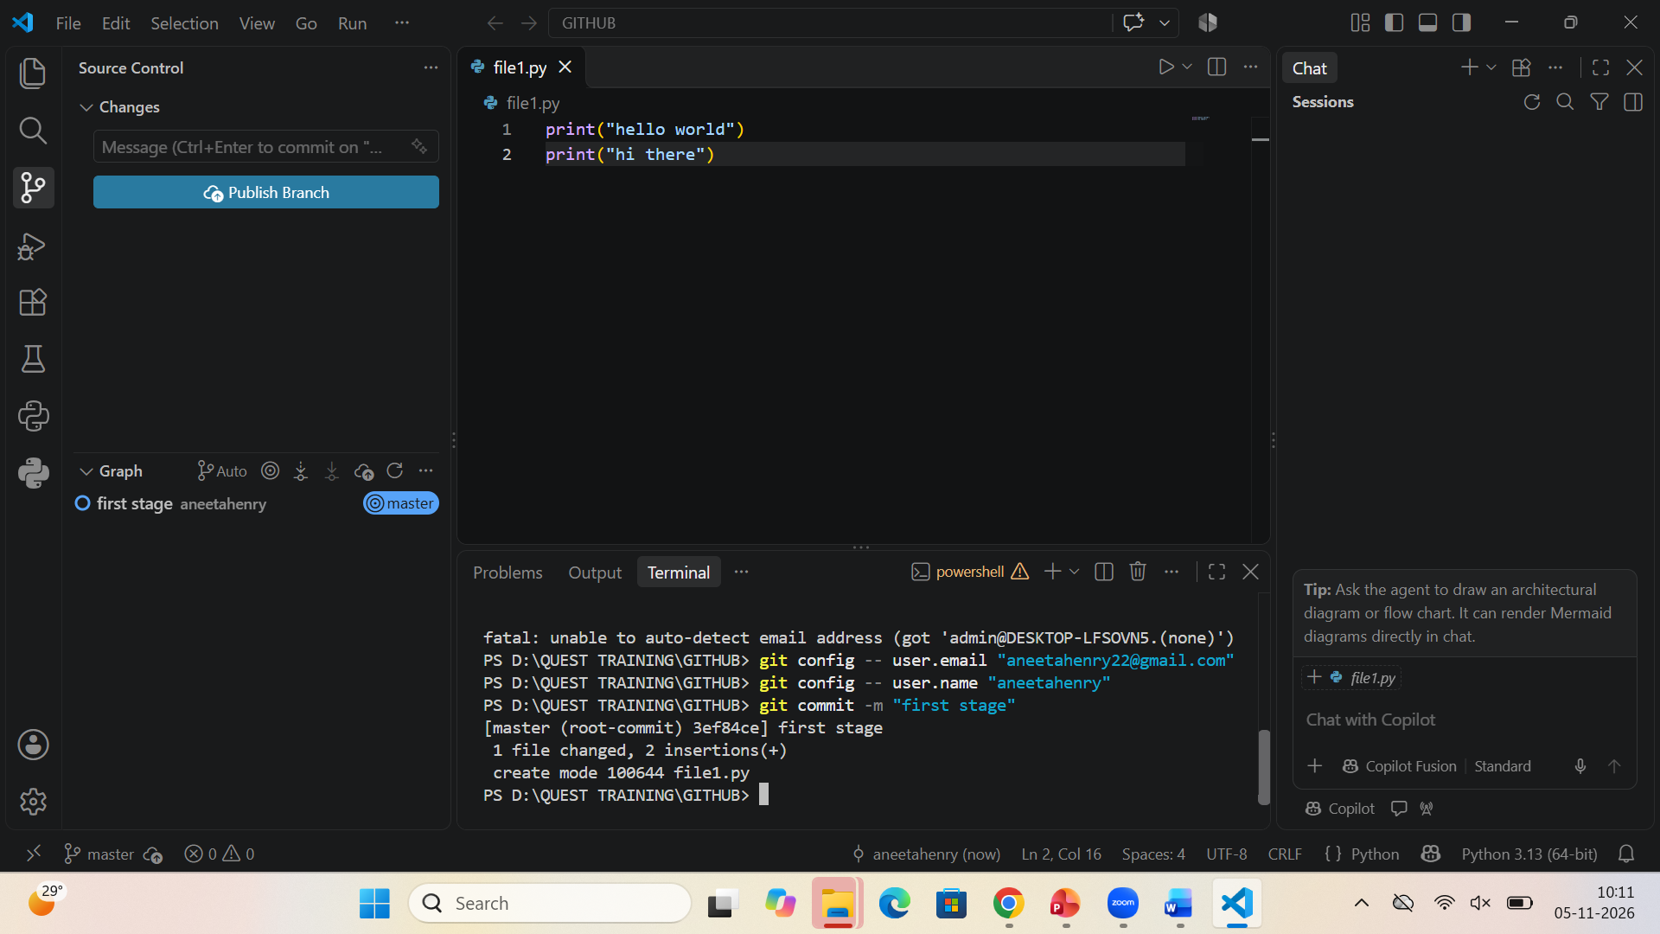

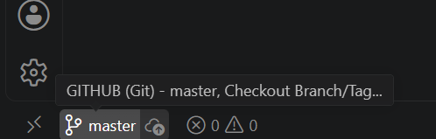
Git name

Create file
Git add
Git commit

Now change the file by adding a line of code: Status M
Then add
Then commit

Now remove the line of code we have added before
Status: M click on the file we can see the changes we have made
All these things we are doing is locally
Terminal git log
We can see what all things we have done
Press enter till it shows END then press Q to return

To get current branch
Git branch

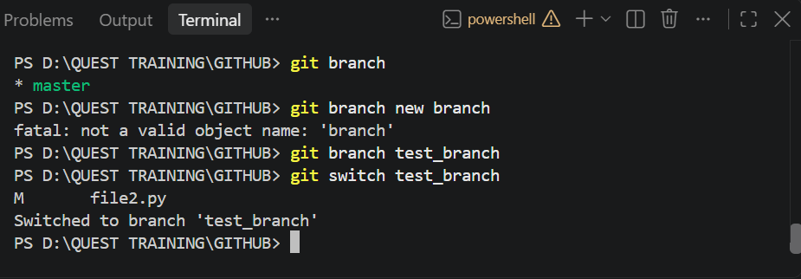

Now we are changing file1 completely
Now : git diff
Enter till END
We can see what all changes are made there
Now we are switching to master branch : there will be no change
Now we have to merge
We have done the changes

